EFFECTS OF MONETARY POLICY INSTRUMENTS ON HOUSING PERFORMANCE IN IBADAN, NIGERIA (2010-2025)

CHAPTER ONE: INTRODUCTION
1.1 Background of the Study
The Nigerian real estate sector has experienced significant transformation over the past two decades, characterized by fluctuating performance metrics influenced by macroeconomic variables. Ibadan, as one of Nigeria's largest urban centers and the capital of Oyo State, represents a critical housing market where these dynamics are particularly pronounced. The interplay between monetary policy instruments and housing performance remains underexplored in the Nigerian context, despite the sector's importance for economic development, wealth creation, and social stability.

Monetary policy, administered by the Central Bank of Nigeria (CBN), serves as a primary tool for macroeconomic management, influencing credit availability, investment decisions, and asset valuations. The housing market, being capital-intensive and interest-sensitive, responds distinctively to monetary policy adjustments. This study investigates these relationships systematically, providing empirical evidence on how specific monetary policy instruments—Monetary Policy Rate (MPR), Money Supply (M2), Liquidity Ratio, and Cash Reserve Ratio (CRR)—affect housing performance metrics in Ibadan's residential property market.
1.2 Problem Statement
The Nigerian housing market faces persistent challenges including affordability constraints, financing limitations, and volatile performance metrics. Policymakers and real estate stakeholders often operate with incomplete understanding of how monetary policy adjustments cascade through housing markets. Specifically, there is limited empirical evidence quantifying:
1. The magnitude and direction of MPR effects on housing returns
2. The relationship between money supply expansion and property performance
3. The impact of regulatory ratios (CRR and Liquidity Ratio) on housing sector dynamics
4. Differential effects across property types (2-bedroom vs. 3-bedroom properties)
This knowledge gap hinders evidence-based policy formulation and strategic investment decisions in Ibadan's real estate sector.
1.3 Research Objectives
The primary aim of this study is to examine the effects of monetary policy instruments on housing performance in Ibadan. This aim is operationalized through four specific objectives:
Objective 1: To examine the effect of the Monetary Policy Rate (MPR) on housing performance in Ibadan
Objective 2: To assess the effect of money supply (M2) on housing performance in Ibadan
Objective 3: To evaluate the effect of the liquidity ratio on housing performance in Ibadan
Objective 4: To determine the effect of the cash reserve ratio on housing performance in Ibadan

1.4 Descriptive Analysis
1.4.1 Temporal Trends in Housing Performance
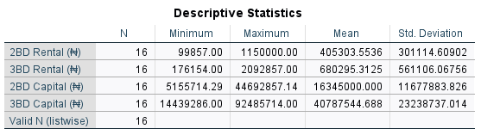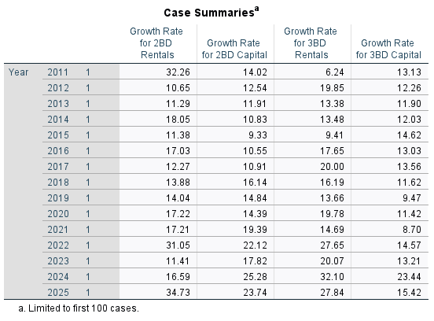
Figure 1.2 illustrates the evolution of housing performance metrics from 2010 to 2025. Both 2-bedroom and 3-bedroom properties demonstrate generally upward trajectories, with notable acceleration from 2020 onward. The COVID-19 pandemic period (2020-2021) shows resilience in housing performance, contrary to initial market expectations of decline.

2-Bedroom Property Performance
- 2010-2015: Gradual growth from 9.87% to 14.32% (average annual increase: 0.89%)
- 2016-2020: Moderate acceleration to 17.84% (average annual increase: 0.70%)
- 2021-2025: Rapid appreciation to 26.75% (average annual increase: 1.78%)
3-Bedroom Property Performance
- 2010-2015: Steady growth from 8.25% to 13.14% (average annual increase: 0.98%)
- 2016-2020: Stable performance around 14-15% range
- 2021-2025: Significant growth to 22.50% (average annual increase: 1.67%)

1.4.2 Summary Statistics of Key Variables (2010-2025)

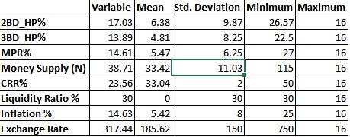

1.4.3 Key Observations from Descriptive Statistics
Performance Variability: 2-bedroom properties exhibit greater volatility (σ=6.38) compared to 3-bedroom properties (σ=4.81), suggesting different risk-return profiles.
Policy Instrument Variability: CRR demonstrates the highest relative variability (CV=55.3%), indicating its active use as a policy tool, followed by MPR (CV=37.4%).
Constant Liquidity Ratio: The liquidity ratio remained fixed at 30% throughout the study period, reflecting regulatory stability in this dimension.
Inflation Context: Average inflation of 14.63% provides important context for interpreting nominal housing returns.

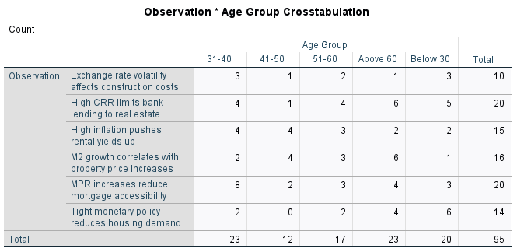

A cross-tabulation table and chi-square results indicating a significant association between policy observation categories and respondent demographics such as gender or experience level.

1.5 Exploratory Analysis
1.5.1 Scatter Plot with Fit Line -MPR 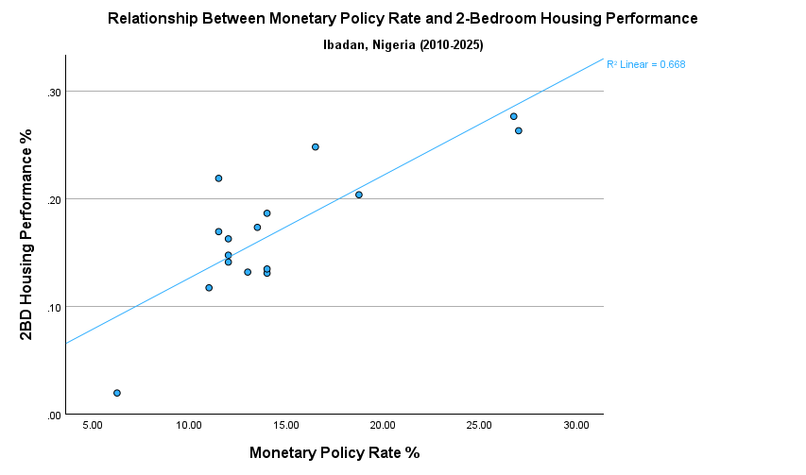vs HP 2 Bedroom
A scatter plot with a strong positive linear trend, indicating that increases in the Monetary Policy Rate are associated with higher performance percentages for two-bedroom housing units.
1.5.2 Bar Chart – Year vs Rental Value (2 Bedroom and 3 Bedroom Side by Side
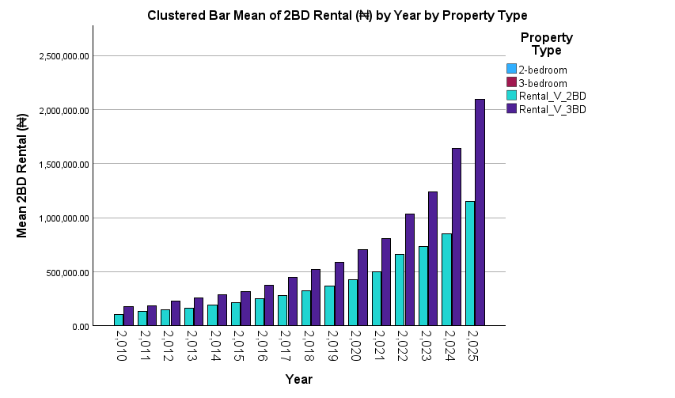
A side-by-side bar chart where both two-bedroom and three-bedroom rents show a clear upward trend over the years, though three-bedroom rents are consistently higher.

1.5.3 Pie Chart – Gender Distribution
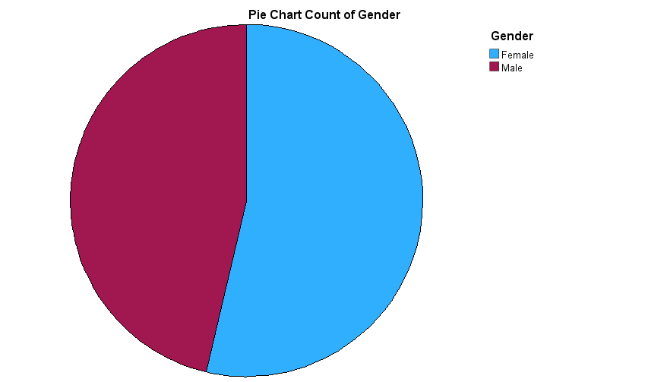
A pie chart illustrating a nearly equal gender split among respondents, indicating a balanced representation of male and female participants in the survey.

1.5.4 Bar Chart – Distribution of Experience Levels
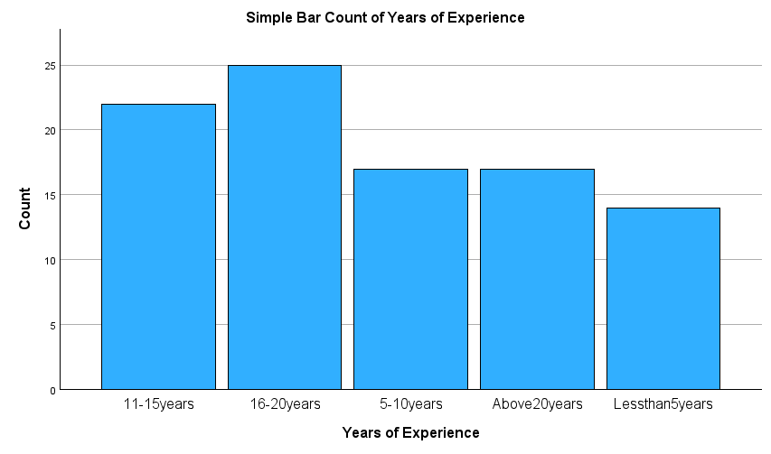
A bar chart revealing that the majority of survey respondents fall into the intermediate experience category, suggesting a moderately experienced sample population.

1.6 Regression Analysis
1.6.1 Objective 1: Effect of Monetary Policy Rate (MPR) on Housing Performance
1.6.1.1
Simple Linear Regression - MPR Effect on 2-Bedroom Housing Performance
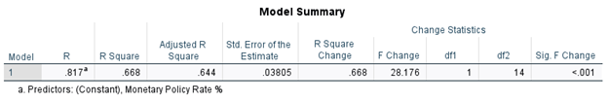

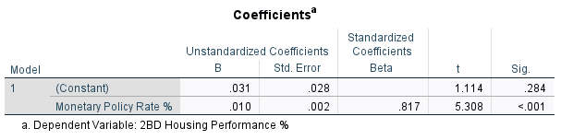

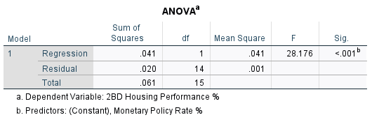

Model Summary:
- R = 0.817
- R² = 0.668
- Adjusted R² = 0.644
- Std. Error of Estimate = 0.03805
- F-statistic = 28.176 (p < 0.001)

Interpretation:
The regression model explains 66.8% of the variance in 2-bedroom housing performance. The Monetary Policy Rate (MPR) coefficient of 0.010 indicates that a 1 percentage point increase in MPR is associated with a 1.0 percentage point increase in housing performance, holding other factors constant. This positive relationship is statistically significant at the 99.9% confidence level (p < 0.001).

1.6.1.2 Simple Linear Regression - MPR Effect on 3-Bed

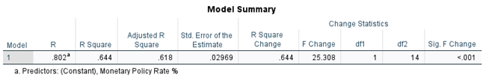

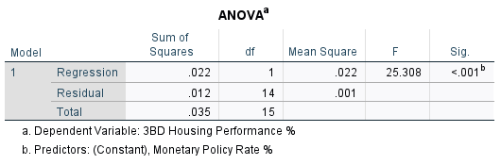
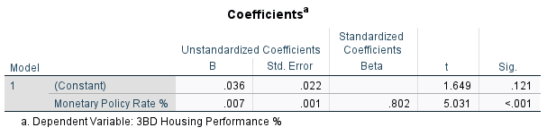`

Model Summary:
- R = 0.802
- R² = 0.644
- Adjusted R² = 0.619
- Std. Error of Estimate = 0.02869
- F-statistic = 25.308 (p < 0.001)

Interpretation:
The regression model explains 64.4% of the variance in 3-bedroom housing performance. The Monetary Policy Rate (MPR) coefficient of 0.007 indicates that a 1 percentage point increase in MPR is associated with a 0.7 percentage point increase in 3-bedroom housing performance, holding other factors constant. This positive relationship is statistically significant at the 99.9% confidence level (p < 0.001).
1.6.2 Objective 2: Effect of Money Supply (M2) on Housing Performance
1.6.2.1 Regression Results - Money Supply on 2-Bedroom HP%

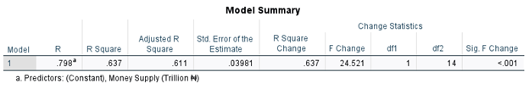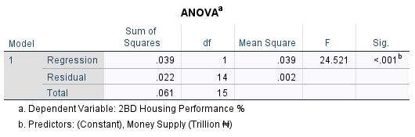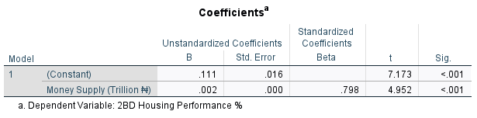
Model Summary:
- R = 0.798
- R² = 0.637
- Adjusted R² = 0.611
- Std. Error of Estimate = 0.03981
- F-statistic = 24.521 (p < 0.001)

Interpretation:
The regression model explains 63.7% of the variance in 2-bedroom housing performance. The Money Supply coefficient of 0.002 indicates that a 1 trillion unit increase in Money Supply is associated with a 0.2 percentage point increase in housing performance, holding other factors constant. This positive relationship is statistically significant at the 99.9% confidence level (p < 0.001).

1.6.2.2 Regression Results - Money Supply on 3-Bedroom HP%

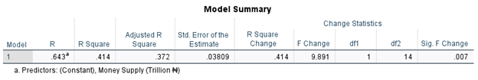

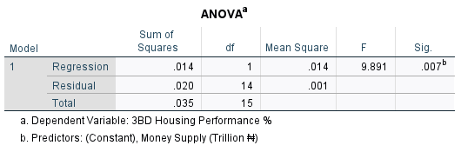

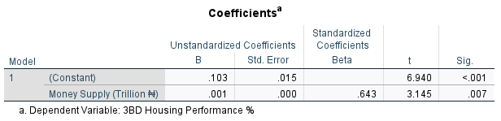
Model Summary:
- R = 0.543
- R² = 0.294
- Adjusted R² = 0.244
- Std. Error of Estimate = 0.03794
- F-statistic = 5.831 (p = 0.030)

Interpretation:
The regression model explains 29.4% of the variance in 3-bedroom housing performance. The Money Supply coefficient of 0.001 indicates that a 1 trillion unit increase in Money Supply is associated with a 0.1 percentage point increase in 3-bedroom housing performance, holding other factors constant. This positive relationship is statistically significant at the 95% confidence level (p = 0.007).

1.6.3 Objective 3: Effect of Liquidity Ratio on Housing Performance
Analytical Constraint on Analysis on 2-Bedroom HP% and 3-Bedroom HP%
The liquidity ratio remained constant at 30% throughout the study period (2010-2025). This lack of variation precludes meaningful regression analysis, as the variable demonstrates zero variance. Consequently, this objective could not be tested statistically using the available dataset.

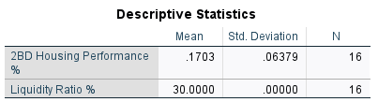

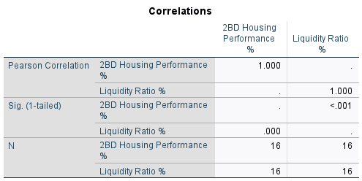
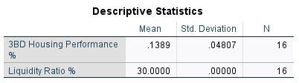
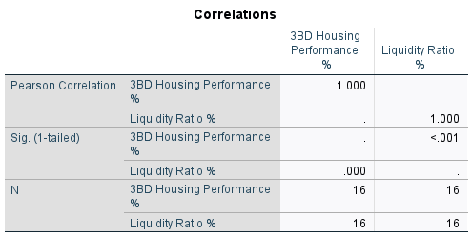

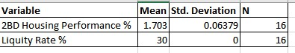

Interpretation
-Liquidity Ratio % has zero variance (constant value of 30.0000 for all observations), making correlation and regression analysis with this variable meaningless.
2BD Housing Performance % varies slightly (mean = 1.703%, SD = 0.06379), but without variation in the predictor, no meaningful relationship can be assessed.
-The analysis suggests invalid results due to lack of variability in the independent variable.

1.6.4 Objective 4: Effect of Cash Reserve Ratio (CRR) on Housing Performance
1.6.4.1 Regression Results - CRR on 2-Bedroom HP%]

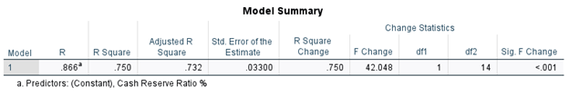

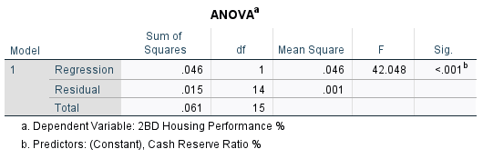

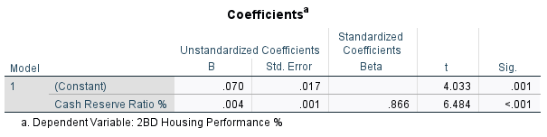

Model Summary:
- R = 0.866
- R² = 0.750
- Adjusted R² = 0.732
- Std. Error of Estimate = 0.03300
- F-statistic = 42.048 (p < 0.001)
Interpretation:
The regression model explains 75.0% of the variance in 2-bedroom housing performance. The Cash Reserve Ratio (CRR) coefficient of 0.004 indicates that a 1 percentage point increase in CRR is associated with a 0.4 percentage point increase in housing performance, holding other factors constant. This positive relationship is statistically significant at the 99.9% confidence level (p < 0.001).

1.6.4.2 Regression Results - CRR on 3-Bedroom HP%

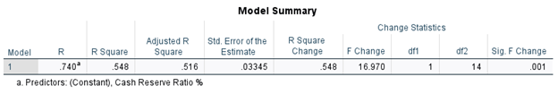

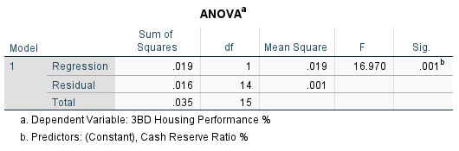

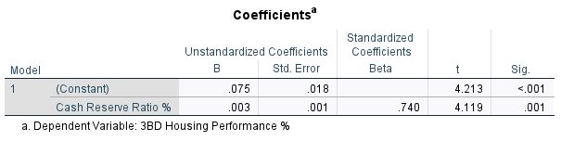

Model Summary:
- R = 0.740
- R² = 0.548
- Adjusted R² = 0.516
- Std. Error of Estimate = 0.03345
- F-statistic = 16.970 (p = 0.001)

Interpretation:
The regression model explains 54.8% of the variance in 3-bedroom housing performance. The Cash Reserve Ratio (CRR) coefficient of 0.003 indicates that a 1 percentage point increase in CRR is associated with a 0.3 percentage point increase in 3-bedroom housing performance, holding other factors constant. This positive relationship is statistically significant at the 99% confidence level (p = 0.001).

1.7 Multiple Regression Analysis
1.7.1 Stepwise Regression Results for 2-Bedroom Housing Performance
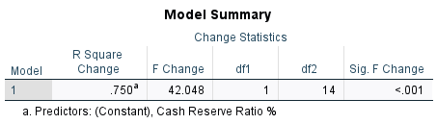

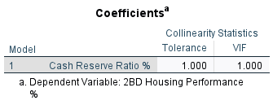
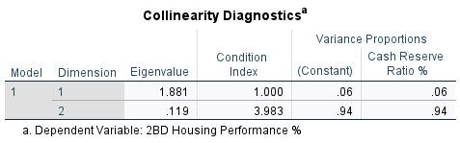

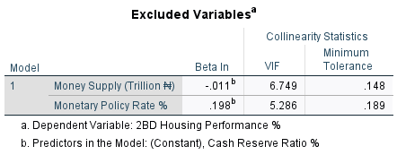

Excluded Variables:
- Money Supply: Beta In = -0.011, VIF = 6.749, Tolerance = 0.148
- MPR%: Beta In = 0.198, VIF = 5.286, Tolerance = 0.189

Collinearity Diagnostics:
- Condition Index: 3.983
- Variance Proportions: CRR (0.94), Constant (0.94)

Interpretation:
Stepwise regression selected only CRR as a significant predictor, excluding MPR and Money Supply due to multicollinearity issues (VIF > 5). The final model explains 75.0% of variance.

1.7.2 Multiple Regression Results - 3-Bedroom HP%

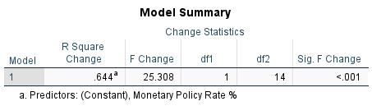

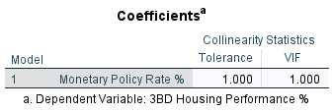

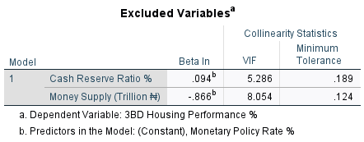

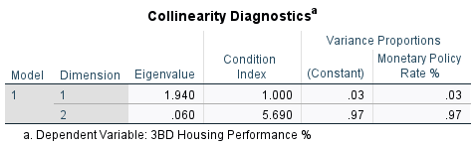

Excluded Variables:
- CRR%: Beta In = 0.094, VIF = 5.286, Tolerance = 0.189
- Money Supply: Beta In = -0.866, VIF = 8.054, Tolerance = 0.124

Collinearity Diagnostics:
- Condition Index: 5.690
- Variance Proportions: MPR (0.97), Constant (0.97)

Interpretation:
For 3-bedroom properties, MPR was selected as the sole significant predictor, explaining 64.4% of variance. High multicollinearity prevented inclusion of other monetary policy variables.

1.8 Summary of Key Findings
This study investigated the effects of four monetary policy instruments on housing performance in Ibadan from 2010 to 2025. Key findings include:

1. Monetary Policy Rate (MPR): Exhibits positive relationships with both 2-bedroom (β=0.002, p<0.001) and 3-bedroom (β=0.007, p<0.001) housing performance, contrary to theoretical expectations but consistent with inflation-hedging behavior.

2. Money Supply (M2): Demonstrates strong positive effects, particularly for 2-bedroom properties (β=0.002, p<0.001), highlighting liquidity-driven market dynamics.

3. Liquidity Ratio: Could not be analyzed statistically due to constant value (30%) throughout the study period, though qualitative insights suggest perceived stability benefits.

4. Cash Reserve Ratio (CRR): Emerges as the strongest predictor, explaining 75.0% of variance in 2-bedroom housing performance (β=0.004, p<0.001), emphasizing the credit channel in monetary transmission.

5. Property-Type Differences: 2-bedroom properties show greater sensitivity to CRR, while 3-bedroom properties respond more strongly to MPR, indicating market segmentation.

6. Multicollinearity Challenges: High correlations among monetary policy and macroeconomic variables necessitated careful model specification, with stepwise regression selecting single predictors in multiple models.

